Use pointers to perform all the tasks given below.
Lab 3 Tasks:

Problem 1) Calculate the volume of a cone using the formula:
Volume of Cone = 1/3 π r² h
Take the values of ‘r’ and ‘h’ from the user. Choose the data types wisely.

Problem 2) Check this mathematical trick for yourself.
Think of a number (and don't forget it). Double it. Add six. Divide your answer by two. Now take away the number you first thought of. The number you get should be... three.
NOTE: Get 1st number from user.
Problem 3) Write a program that takes 5 integers from the user and displays the sum, average and product of these numbers on screen.

Problem 4) Write a program that gets marks of 5 subjects from user and then calculates the percentage and display result on screen.

NOTE: Get marks of Calculus, Programming, E and M , fundamentals of CS, Islamiat from user. Assume total marks of each subject is 100.

Problem 5) Write a program that calculates the remainder and quotient of two numbers entered by user and display the answers.

NOTE: Get numbers from user.
Problem 6)
Write a program that asks the user for three floating-point values. The program should compute square of each value and add them together. Then, display the result.

Problem 7)
Take two inputs from user and write a C++program to perform the following operations
x = a² + 2ab + b²

Problem 8)
Take user input for a lower case alphabet (small letter) and convert it into upper case (capital letter)

Problem 9)
Take user input for an alphabet and print its ascii value.

Problem 10)
Write a program to get number of minutes from user and convert it into hours and then print the result.

Sample Output:
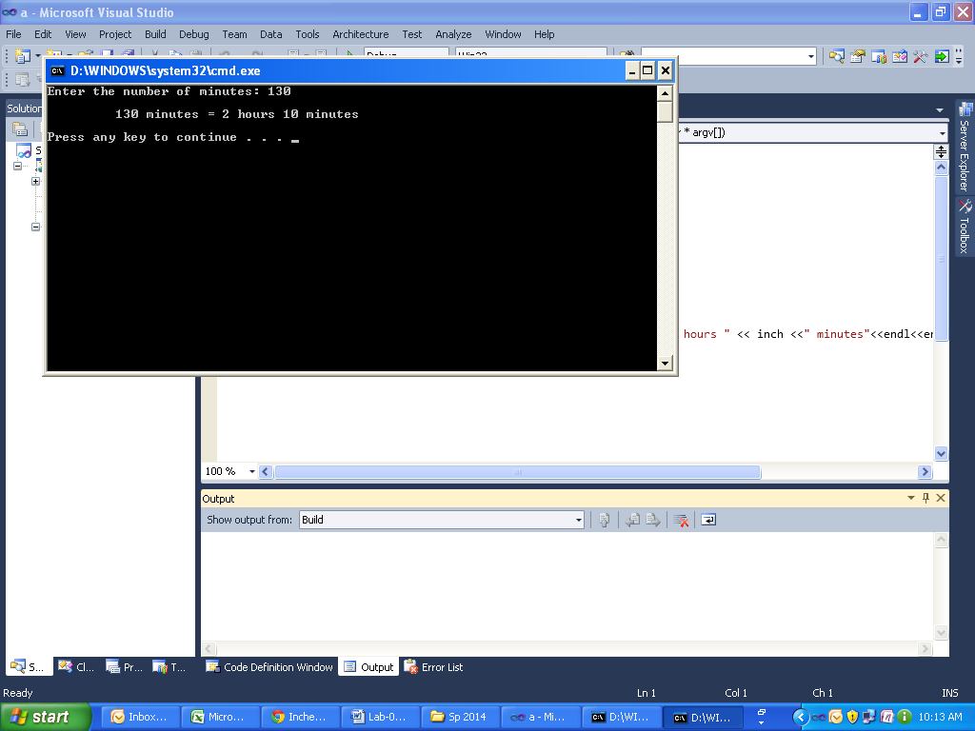

**********GOOD LUCK**********

